### শিক্ষা নিয়ে গড়বো দেশ তথ্য-প্রযুক্তির বাংলাদেশ

**Bangabandhu Sheikh Mujibur Rahman Digital University, Bangladesh**

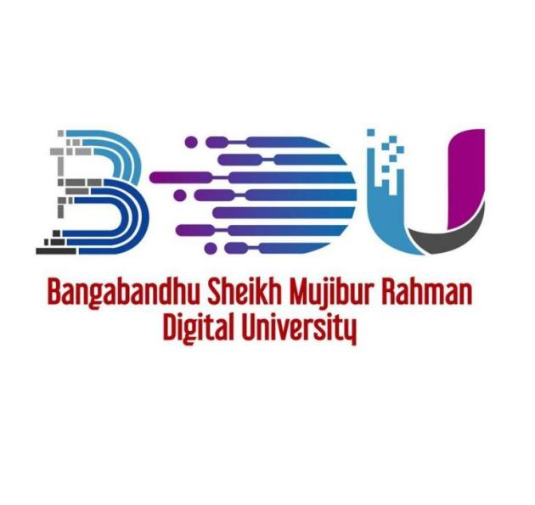

**ASSIGNMENT NO: 01**

**COURSE NO.-DS 107**

**COURSE TITLE-PROBABILITY AND STATISTICS**

**SUBMITTED BY**

Mehrin Farzana

ID: 2101013

Session :2021-2022

Department of IRE, BDU

**SUBMITTED TO**

Md. Mehedi Hasan

Lecturer (Mathematics)

Department of General Education, BDU

**Date of Submission: 21 April, 2024**